**Automate an E-Commerce Web Application**

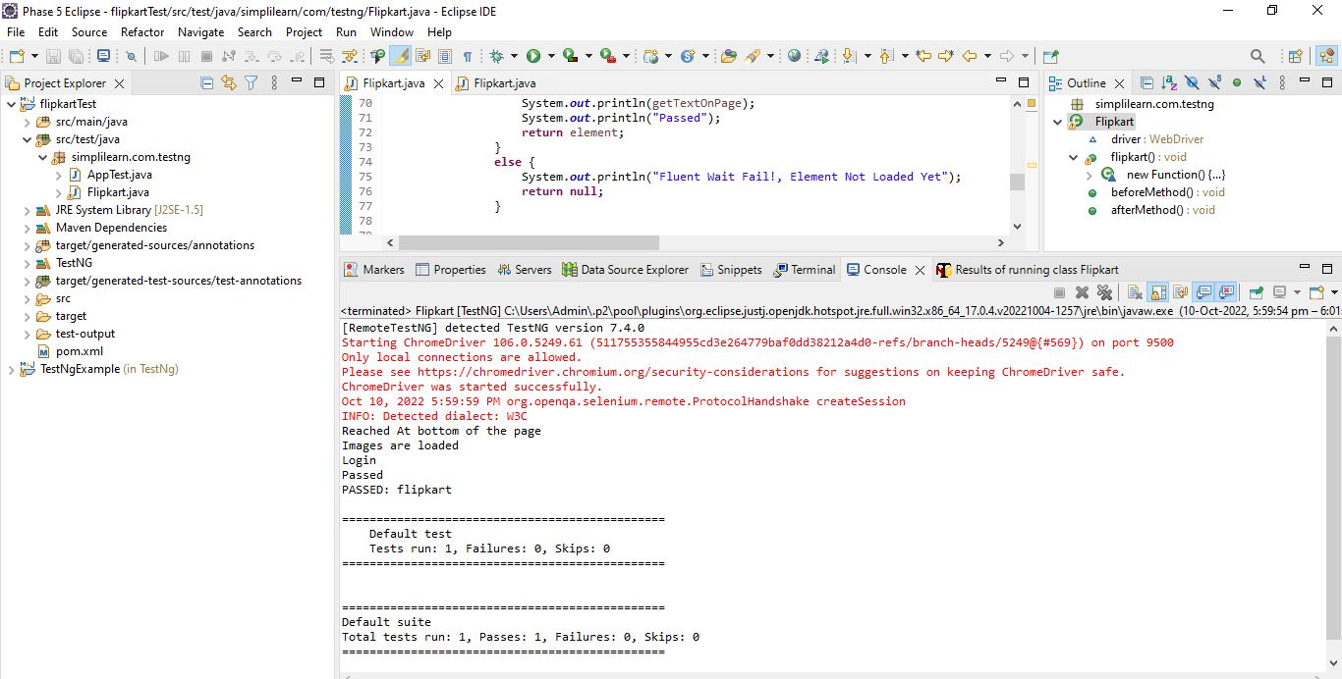

* Project is executed without error

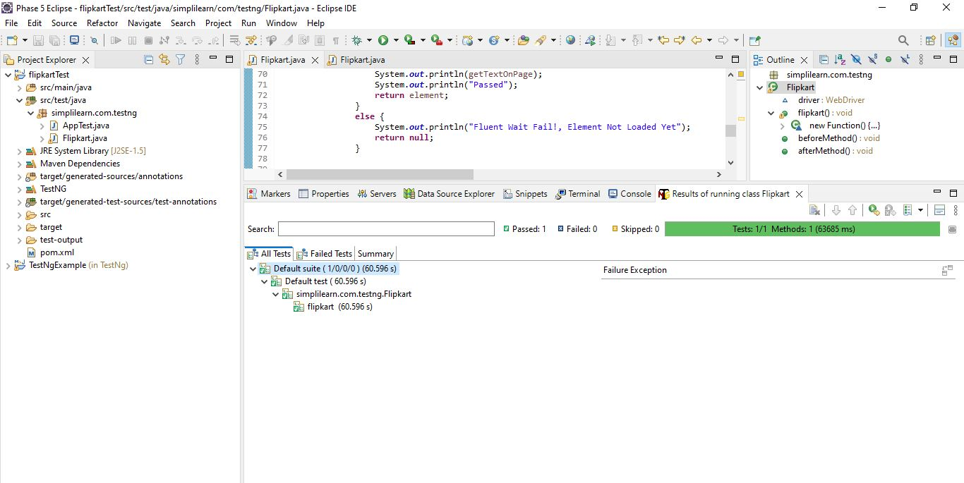

All the test cases are executed without error

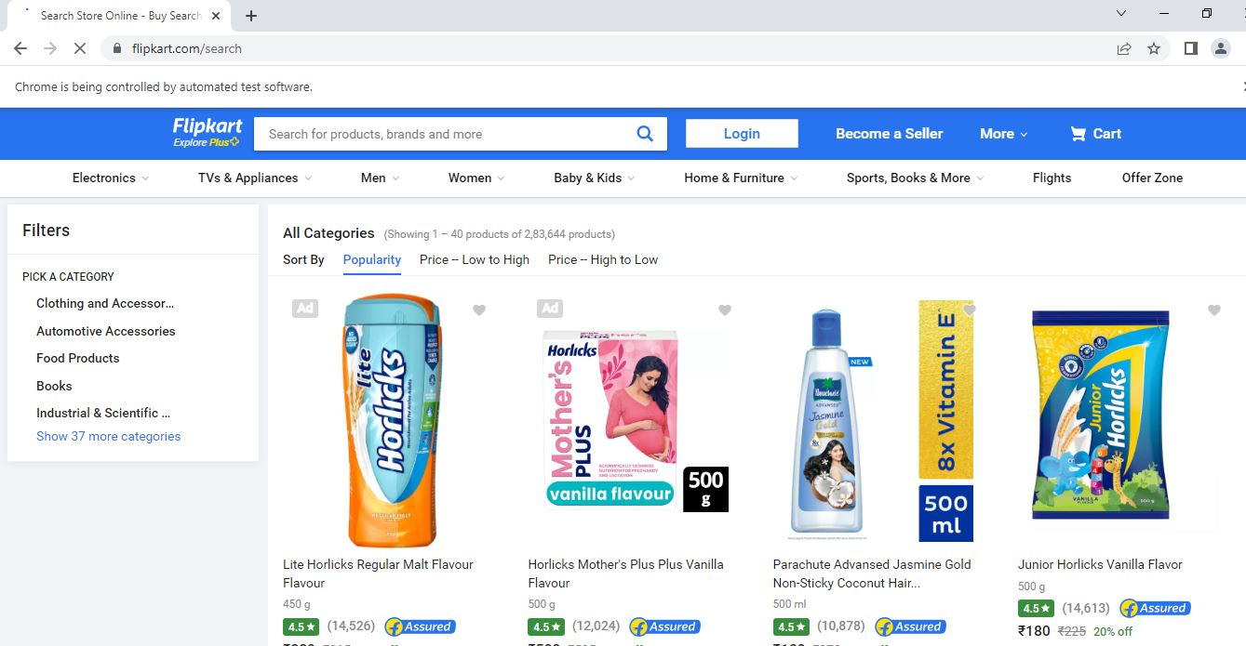

* Flipkart is opened with specified web link in code.
* It opens the page and loads the content.

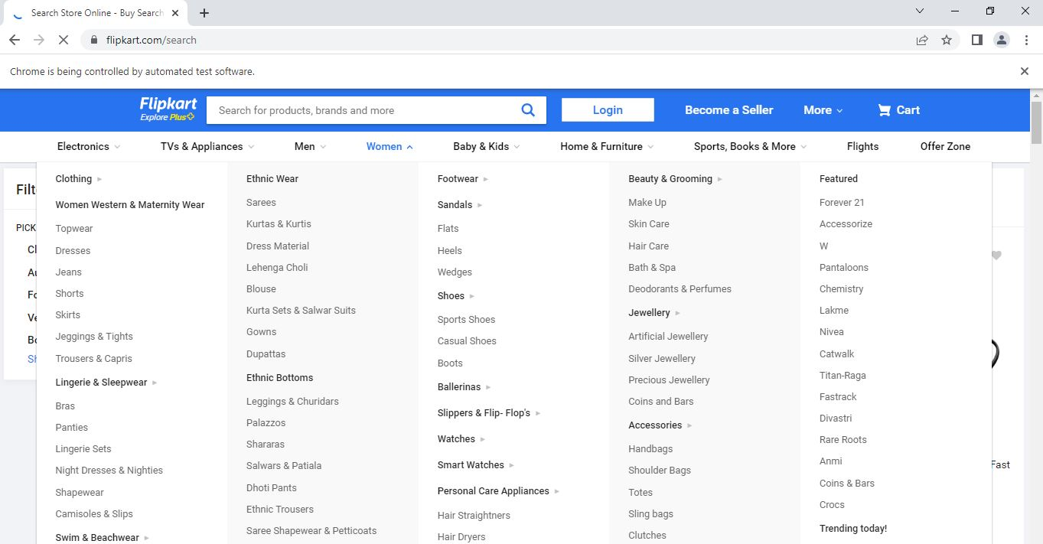

* It clicks on search button to search for iphone 14
* And iphone 14 will be displayed

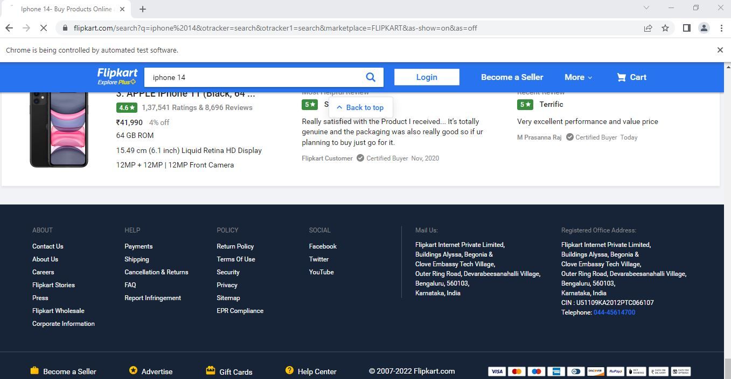

* Scrolling will be done from top to bottom.
* Frequency is calculated during the scroll
* Image loading is calculated.
* A message is displayed when scroll is reached at the end of the page

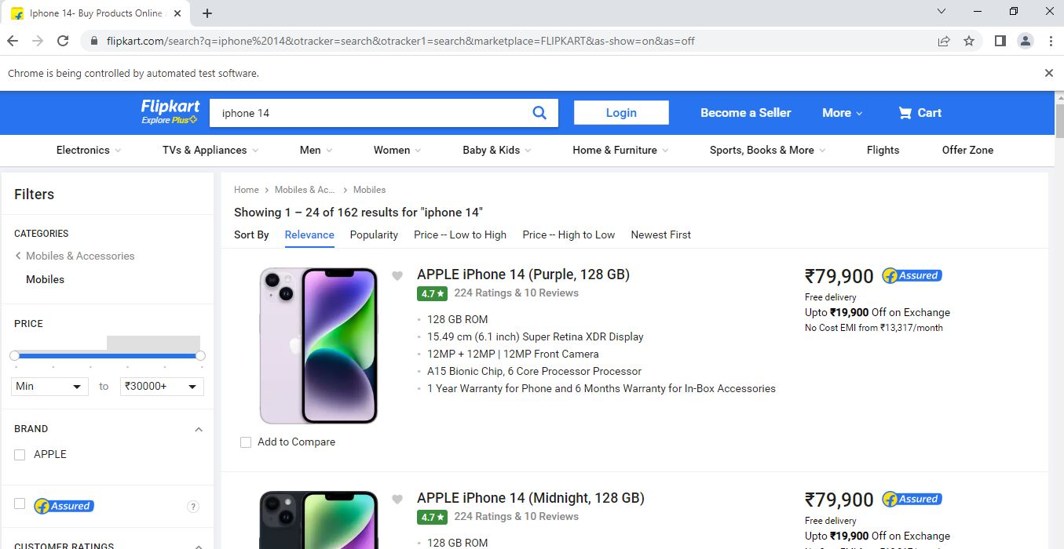

* The page is loaded and image is displayed.